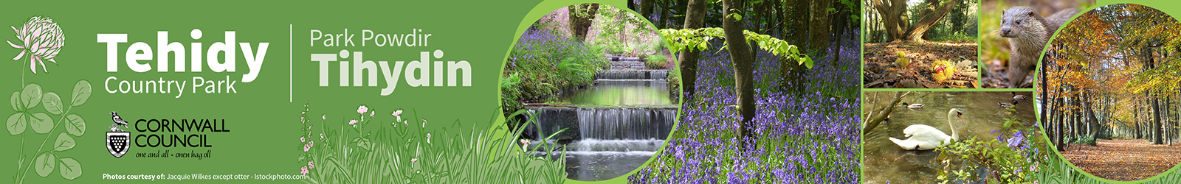

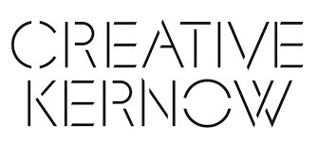


Tehidy Creative Residency Programme
Supporting Information for Applicants
How to Apply
Contents
- Eligibility 1
- Selection Criteria 2
- Evaluation Process 3
- Application Process 4
- Summary of Deadlines 4
- Where to find more information 4

Eligibility
Any artist can apply for a maximum of one residency per year.
Our definition of artist is in the broad sense of anyone creating a creative output, for instance including:
- Painting  - Sculpture – (we have outdoor space for materials such as stone, metal, wood etc.)  - Advertising and marketing  - Architecture  - Crafts  - Culture & Heritage  - Design: product, graphic and fashion  - Film, TV, video, radio and photography  - IT, software and computer services  - Experiential and immersive creative outputs | - Publishing  - Music, performing arts  - Visual arts  - Photography  - Written and/or spoken word  - Performance  - On-line creative outputs  - Multi-media creative outputs
This list is not exhaustive, and we encourage anyone with a proposal that they consider to be relevant to apply.
Whilst on the Creative Residency the artist will be self-employed and will need to demonstrate appropriate insurances and risk assessments as part of the application process (A template risk assessment will be made available).
We will require proof of your permanent residential address.
Single occupancy restriction:
Please note that whilst teams of artists are welcome to apply, it is not possible to have more than one occupant in the cottage at any one time due to restrictions on use of the building.
If you are a team of artists and considering applying, we strongly recommend contacting us in advance so that we can discuss how the residency might be facilitated, noting that due to the single occupancy restriction it may not be possible.

Selection Criteria
Applications will be evaluated on the following criteria and scoring:
Stage 1: Shortlisting
Quality of creative outputs:  - Prior experience  - Evidence of prior outputs  - Clarity and quality of the presentation of intended outputs  - Interpretation of how the outputs will interrelate with Tehidy | 50%
Proposals for engagement, including relevance to Tehidy, possible appeal to the local community and proposal for widening the audience engaged with the Country Park. | 30%
Intended outputs are in keeping with the ethos of the site as a Country Park. | 20%

Stage 2: Gateway Process (successful applicants will need to confirm that if not in place on application these criteria will be met in advance of commencement).
Check of at least one form of the following formal ID including confirmation of the right to stay in the UK  - Passport  - Driving licence  - Birth certificate | Pass/Fail
Submission and approval of a risk assessment | Pass/Fail
Confirmation of public liability insurance of a value not less than £5 million | Pass/Fail
Confirmation of personal / business possessions and personal injury insurance – The Residency managers take no liability or responsibility for loss, damage or injury to the supplier or beneficiary as a consequence of the Creative Residency | Pass/Fail
Signed license to occupy | Pass/Fail
Confirmation of Registration with the Inland Revenue as self-employed?
Cleared the Enhanced Disclosure and Barring Service (DBS) checks.  Please note that this will be applied for by the Residency manager and at the applicant’s expense with the fee currently at £38.00 for a new application: Check someone's criminal record as an employer: Get a standard or enhanced DBS check for an employee - GOV.UK (www.gov.uk) | Pass/fail
Demonstration of suitability and self-sufficiency | Panel members assessment
Deposit of £250 payable in advance of the start of your residency  Deposits will be calculated and returned following an end of residency handover meeting between the artist and the manager at the cottage. | Pass/Fail

Evaluation Process
An evaluation panel will be used at the shortlisting stage, which will comprise of staff from Creative Kernow and a representative from Cornwall Council, or their nominated delegate.
Each member of the panel will first evaluate applications and score the applications independently, based on the criteria at stage one (above).
The resulting scores will then be averaged, and the rank list will be considered by Creative Kernow, who have the right to suggest a reordering for consideration by the evaluation panel.
Please note that Creative Kernow and Cornwall Council reserve the right not to award any residencies and to hold subsequent rounds of applications.
Applicants have the right to ask who their evaluation panel will be in advance of any interview that may be offered following on from successful shortlisting and this information will be provided to the best of the Manager’s ability though may be subject to change.

Submitting an Application
Applications are invited using the application form available at: the Krowji website or by contacting Krowji.
Applications need to explain how your creative residency proposal will meet the criteria outlined above.
Prior to application there is an opportunity to submit questions and arrange a site viewing.
Site Viewing
Tehidy Country Park is a public space and can be visited for free everyday between dawn and dusk.
The cottage and curtilage are not publicly accessible, however viewing may be arranged by contacting charlotte.evans@cornwall.gov.uk
Questions Prior to Application
Any questions prior to application should be submitted to info@krowji.org.uk no later than Tuesday 27th August 2024.
Submission details
Applications should be submitted by email to info@krowji.org.uk before 5pm on Friday 6th September 2024.
If you require your application to be submitted via an alternative format for equality reasons, you should contact us about it before Friday 30th August 2024 so that arrangements can be made within the comparable timeline.

Summary of Deadlines
Applications Open: Monday 5th August 2024
Submission of Questions: No later than Friday 27th August 2024
Application Deadline: 5pm on Friday 6th September 2024

Where to find more information
Tehidy Let’s Talk Page: https://letstalk.cornwall.gov.uk/tehidy
Krowji website: https://www.krowji.org.uk/
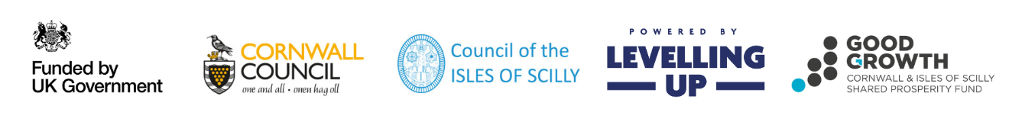
Contact Krowji: Email: info@krowji.org.uk | Tel: 01209 313200
This project is part funded by the UK Government through the UK Shared Prosperity Fund. Cornwall Council has been chosen by Government as a Lead Authority for the fund and is responsible for monitoring the progress of projects funded through the UK Shared Prosperity Fund in Cornwall and the Isles of Scilly.

