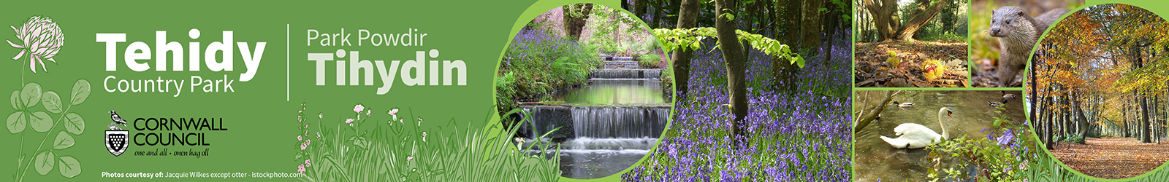




Tehidy Creative Residency Programme
Background Information
Contents
- Background to the Initiative 1
- About Tehidy Country Park 1
- Tehidy Creative Residency Programme Information 3
- The Creative Residency Offer 5

Background to the Tehidy Creative Residency Programme
Tehidy Country Park is a much-loved public site of predominantly woodland, used by local residents and visitors for outdoor rest and relaxation through activities such as walking with friends and family, dog walking, cycling, running and horse riding.
Today it is the largest woodland in west Cornwall but has a long history as the seat of the western branch of the influential Basset family, with the site occupying the grounds of a former landscaped parkland, designed and implemented largely in the 18th century in a recognisable ‘Capability Brown’ style.
Nestled close to the edge of the woods is a hub of buildings around a former kennels complex, which includes two former estate workers cottages.
Cornwall Council was successful in applying for Shared Prosperity Funding (SPF) to rehabilitate one of the cottages into a creative residency, as a venue for artist-led creative projects focused on producing outputs inspired by Tehidy Country Park and with the core goal of engaging a wider, more diverse audience in the site.
The Tehidy Creative Residency Programme is part of a wider Tehidy Creative Community and Wellness Resource Project which will also deliver a cultural community and wellness resource centre in a second cottage next door to the creative residency, along with an extensive activity and skills training programme of events and the Poetry Privy artist-led project to reimagine a former toilet hut.

About the Country Park
Ethos and Vision
It is our vision that Tehidy will become an exemplar site for sustainable management of a public Country Park, demonstrating excellence in nature conservation and cultural value for residents of Cornwall:
- All regeneration or new development will be in keeping with the ethos of a Country Park and will embed sustainability.
- The park will become net zero carbon and support the community in living lower carbon lifestyles through providing opportunities for active lifestyles and demonstrating low carbon initiatives.
- Tehidy will act as a hub destination in the Cornwall AONB, helping it to be a thriving, connected and well protected landscape where habitats are nature-rich and connected.
- Tehidy will support a vibrant business community through on-site opportunities and Cornwall Council will require and encourage those businesses to act sustainability and regeneratively (key sectors include wellbeing and regenerative tourism and the creative industries).
- Heritage will be well conserved and harnessed to create interest for visitors and a positive sense of place for the local community.
Important note: Tehidy Country Park is a freely accessible public open space
Whilst this is a less-well-used part of the Park, the intention of the Creative Residency is to increase and diversify the audience engaging with Tehidy and as such all creative residents will need to be comfortable and cooperative with the safe and free enjoyment of the wider Park by the general public.

Tehidy Creative Residency Programme Information
The Tehidy Creative Residency Programme has been established to provide opportunities for creatives to progress their career and contribute towards positive growth in Cornwall’s creative and cultural sector. The objectives are:
  - Use creative outputs to increase engagement with Tehidy Country Park, in particular with groups identified as suffering barriers to experiencing the outdoors.
  - Evidence how creative outputs help increase engagement with Tehidy Country Park, in particular with groups identified as suffering barriers to experiencing the outdoors.
Residency Managers: The Tehidy Creative Residency Programme is being managed jointly by Cornwall Council Natural Environment Service and Creative Kernow (also referred to as Krowji).
Main contact:
Krowji, as part of Creative Kernow, will be supporting Artists develop their proposal, career direction and publicity of outputs during their project period.
Equally, for guidance with your application and information relating to the residency please contact Krowji.
Email: info@krowji.org.uk | Tel: 01209 313200

Kennels Cottage: The space offered for the duration of the residency is a detached stone-built former estate workers cottage located at the Kennels area of Tehidy Country Park, between Camborne and the North Cliffs in west Cornwall. It is accessed from the B3301 road between Portreath and Hayle.
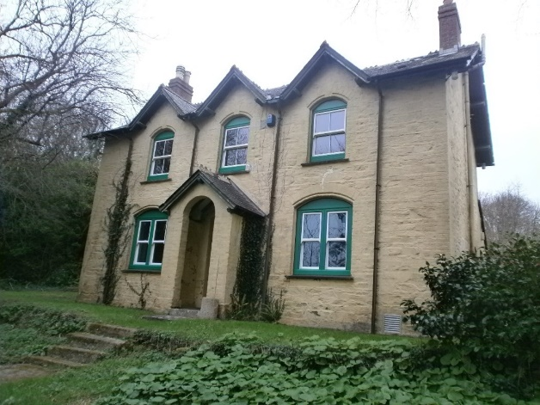
Upstairs the cottage has two double bedrooms and one smaller room suitable for a single bedroom or study. Whilst downstairs there is a good-sized kitchen, separate living room that has been transformed into the studio space and bathroom with shower over the bath.
The studio space includes an artist’s desk, general office furniture and good quality lighting. You will need to supply all of your own materials and any specialist equipment, and all IT (laptop, phone) resources.
The cottage has wifi throughout, which is provided by Cornwall Council. Use of this resource must adhere to the expected standards of conduct, should be connected to your creative work and cannot be used to access illegal or inappropriate web content.
There is a garden to the front and the back, beyond which you step into the publicly accessible Country Park, which includes a campsite field across the track that runs to the front of the garden.
During the residency, creatives using the space will be responsible for general facets of building security as if it were your own property, for instance ensuring that appliances are used safely, the fire detection and alarm system is not turned off and that the building is locked.
There is no obligation to stay at Kennels Cottage throughout your residency – it may be used simply as a studio space or can used for holding engagement activities on-site as part of your outputs.
Successful applicants who do wish to stay at the cotta during their project period will be asked to enter into a Licence to Occupy with Cornwall Council.
All activities on the site will require a Risk assessment and suitable insurance, for which the Artist is responsible and must be shared with Cornwall Council.
Contact details for site matters will be provided to successful applicants.

Restrictions on use of the cottage:
Artists will be invited to use the cottage only for the purpose of delivering the Creative project agreed with the Residency Managers through the application process. Any chages to the proposal need to be discussed and agreed with the Residency Managers before implementation.
- Use of the cottage shall be shall be time-limited under a Licence to Occupy.
- Whilst on the residency programme Artists will be strictly prohibited from registering the residence as your postal address for any product, service or communication.
- Only artists involved in delivering outputs of the residency shall be permitted to occupy the space. This means that it is not possible to allow family members or others to stay in the space provided.
Single occupancy restriction:
Please note that whilst teams of artists are welcome to apply, it is not possible to have more than one occupant in the cottage at any one time due to restrictions on use of the building.
If you are a team of artists and considering applying, we strongly recommend contacting us in advance so that we can discuss how the residency might be facilitated, noting that due to the single occupancy restriction it may not be possible.

The Creative Residency Offer
Successful applicants will be offered a project period with a maximum of 3 months residency opportunity.
The aim is that this opportunity gives Artists the opportunity to immerse within the setting and culture of Tehidy Country Park, as an inspiration and impetus for their project outputs.
Apart from having use of the cottage Artists will be expected to be self-sufficient throughout the duration of their agreed project.
- There will be no payment or compensation for time
- There is no catering or materials budget
- The creative programme does not pay for the outputs, but provides a space and setting for you to progress your work for free
- Support offered by Creative Kernow is intended to help progress creative careers and grow the creative sector in Cornwall
- A deposit of £250 is payable before the start of your residency. The deposit will be held in case of any property damages resulting from your residency but will be refunded to you following a satisfactory end of residency property review with the Residency Managers – Participants are encouraged to review the pre-start record of condition before they start their Residency.
You will benefit from having residency of the cottage at no charge, which offers a sanctuary for you to develop your creative outputs related to your experience of Tehidy.
The residency programme provides the space for free; utilities bills will also be covered up to a maximum of £100 per month, over which amount the Residency Managers reserve the right to review the costs and seek reimbursement from the project appointee.
Residents will have access to support in promoting their outputs via Creative Kernow.


This project is part funded by the UK Government through the UK Shared Prosperity Fund. Cornwall Council has been chosen by Government as a Lead Authority for the fund and is responsible for monitoring the progress of projects funded through the UK Shared Prosperity Fund in Cornwall and the Isles of Scilly.
This project is part funded by the UK Government through the UK Shared Prosperity Fund. Cornwall Council has been chosen by Government as a Lead Authority for the fund and is responsible for monitoring the progress of projects funded through the UK Shared Prosperity Fund in Cornwall and the Isles of Scilly.

